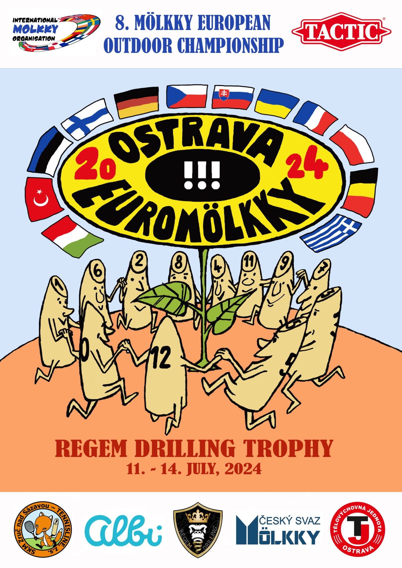
8. Mölkky European Outdoor Championship
EUROMÖLKKY 2024
REGEM DRILLING TROPHY
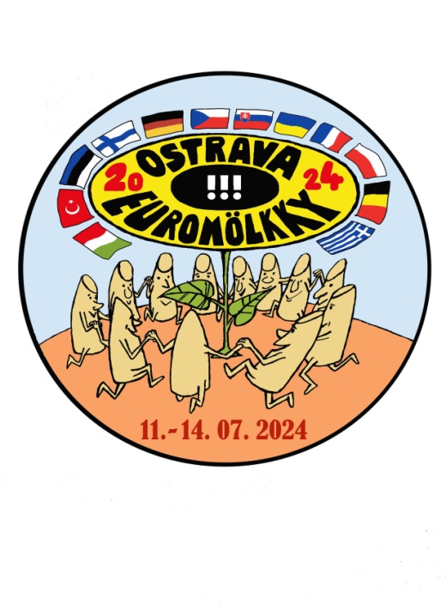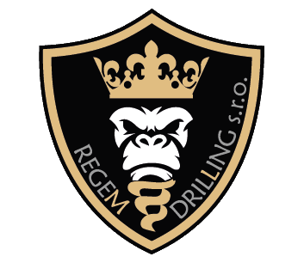
Organizer: Czech mölkky association + SKM Zruč nad Sázavou – Tennisline, z. s. Na Výsluní 752, 285 22 Zruč nad Sázavou
Contact person: Leos Fiala, Dvouletky 710, 285 22 Zruč nad Sázavou leos.fiala@volny.cz, m. +420-777 922 395
Organizing committee: Leoš Fiala chairman leos.fiala@volny.cz m +420 – 777 922 395
Dagmar Tesařová Tournament Director m. +420-733 559 313 Ing. Radim Freisler Tournament Director Ass. m. +420-602 404 680
Jaroslav Chmelík referee jaroslav.chmelik@seznam.cz Stanislav Ozimý referee assistent
Petr Hanyk, Vojtěch Plecháč results processing Michal Osovský technical operative
Date of Championship: 11. – 14. 07. 2024
Venue of Championship: TJ Ostrava – sport area, www.tjostrava.cz Varenská 3098/40a, 702 00 Ostrava, Czech Republic
Number of participants: no limited
Registration: must be done during 01. 01. – 16. 06. 2024 at website www.euromolkky.cz
Starting fee: 80 Euro for team – EUROMÖLKKY 2024 13-14.07.24 12 Euro for player – BEACH OPENING 11.07.24 25 Euro for team –DOUBLES WARM UP 12.07.24
Teams: each team consists of 3 – 4 players, captain of the team must be above the age of 18
Fields: 32 numbered fields, 6 x 12 m, red clay surface
Mölkky: games are always played with official Tactic
Restaurant and sanitary facilities: in the sports area TJ Ostrava
Accommodation: to be specified , www.booking.com
Medical service: non-stop first aid trained staff
Alcohol: alcoholic beverages are prohibited in the playing fields
Smokin g: smoking is prohibited during the game, allowed only in designated areas
Referees: official referees at each field are nominated by the organizer (for semi-finals, finals and bronze medal match)
Prizes: medals, cups and material prizes for teams in 1.– 3. place of European Championship medals for teams in 4.– 10. place of European Championship medals and plaques for teams in 1. – 3. place of Last chance Tournament
medals, cups and teams in 1.– 3. place of Europe Cup
medals and plaques for players in 1. – 10. place of Beach Opening
medals and plaques for teams in 1. – 6. place of Doubles Warm Up
Rules: official I. M. O. mölkky rules are followed, throw is delimited by Mölkkaari
Playing system: EUROMÖLKKY 1st Phase groups
2nd Phase play off
BEACH OPENING Finnish groups
DOUBLES WARM UP groups and play off
EUROPE CUP play off and placement matches
Time schedule:
01. 01. – 16. 06. 2024 e-mail registration at www.euromolkky.cz
Tuesday 18. 06. 2024 18:00 draw
Wednesday 19. 06. 2024 12:00 release of draw results and time schedule at website www.euromolkky.cz
Thursday 11. 07. 2024 17:00 – 21:00 BEACH OPENING tournament max. 48 players
Friday 12. 07. 2024 13:00 – 18:00 DOUBLES WARM UP tournament max. 48 teams
16:00 – 21:00 presentation, issuing of starting numbers, training, friendly matches

Saturday 13. 07. 2024 08:30 – 9:45 presentation, issuing of starting numbers
09:45 opening ceremony 10:00 matches in groups
16:30 EUROPE CUP – nation teams
Sunday 14. 07. 2024 09:30 1st and 2nd round of Last Chance Tournament 10:00 Play off matches 15:00 Last Chance Tournament final and bronze medal match 15:15 European championship – bronze medal match 16:00 European championship final 17:00 medals closing ceremony

